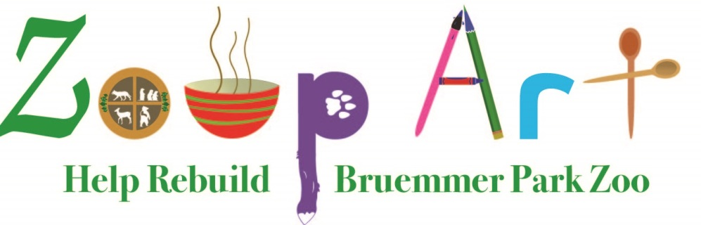
Registration Form
All Soup Makers
Your Name as you would like it listed on all advertising

Phone Number_____________________________________________
Email Address______________________________________________
Best Time to Contact ________________________________________

Name of Soup (Must be provided no later than February 1, 2019)
__________________________________________________________

Mail or Email Completed form to:
ZSKC
E4280 County Road F
Kewaunee, WI 54216
info@bruemmerparkzoo.com

